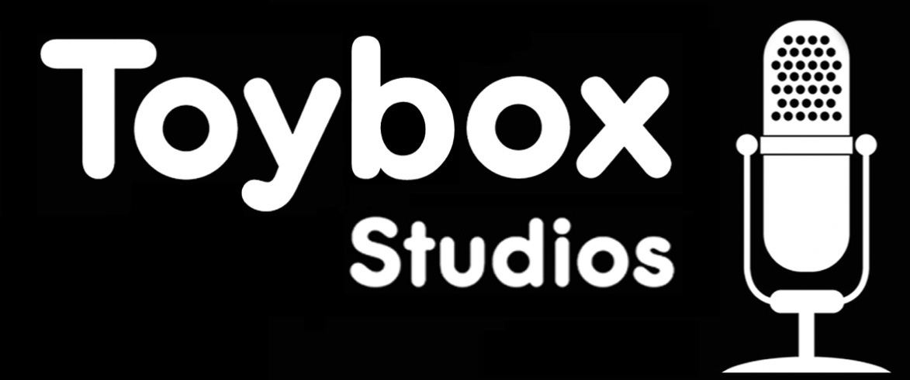

Training Course Booking Form

Please complete the following information as clearly as possible and return to:
Toybox Studios

25 Portland Square
Bristol
0117 9892642

Course Title: | Date: | Fee Payable:  (Full Price £85 or Early Booking Discount £60 which must be received by the 31 October 2008)

Name:

Contact address:

Postcode:
Contact tel. No:

Contact email:

What music experience do you have? (For example do you play an instrument, do you make your own music, or are you studying at college? If your experience is limited this is fine)

Do you have any special needs or dietary requirements we need to know about?

Payment Information: Please sign and return with a cheque made payable to Toybox Studios.

All cancellations, transfers and other changes to bookings must be confirmed in writing, by email or fax.
Cancellations received more than 14 days before the course may be subject to a £30 administration fee.
For cancellations received less than 14 days before the course date no refund will be made if we are unable to fill the place on the course.

I have read and understand the booking and cancellation terms

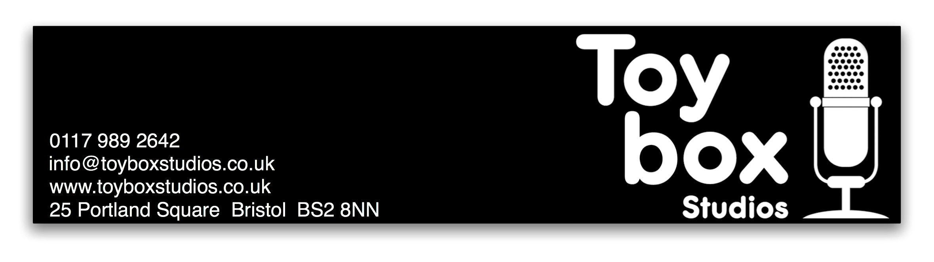
Signed ___________________________________________ Date ______________________

